

Unity Composite
High School

Unity Composite High School
Student Handbook
2021 - 2022

Mr. A. Melnyk
Principal
Mr. K. Parker
Vice-Principal

Box 1000
Unity, SK, S0K 4L0

Phone: (306) 228-2657
Fax: (306) 228-2228
Email: uchs@lskysd.ca
Website: https://uchs.livingskysd.ca/

UCHS STAFF
Principal Mr. A. Melnyk
Vice-Principal Mr. K. Parker – Room 105

Teachers: Room #
Ms. B. Arsenault 213
Ms. K. Huber 201
Mr. R. Cey 205
Mrs. J. Clark 203
Mr. K. Clark 124
Mrs. A. David 202A / 204
Ms. R. Gartner 106
Ms. N. Krips 123
Ms. K. Nett 212
Mrs. V. Orobko 107
Mr. M. Poirier Shop
Mrs. H. Poitras 121
Ms. M. Riddell 210
Mrs. K. Snell 141
Ms. M. Van De Meutter 103
Ms. K. Wintonyk 221
Mr. K. Wood 206

Support Staff: Position
Mrs. C. Bretzer Secretary
Mrs. S. Chorney Educational Assistant
Mrs. V. Gilbert Secretary
Mrs. M. Herzog Educational Assistant
Mrs. C. Keifer Educational Assistant
Mrs. S. Keller Educational Assistant
Mrs. C. Loadman Educational Assistant
Ms. D. L’Heureux Library Technician
Mrs. G. Phillips Educational Assistant
Mrs. K. Salewski Educational Assistant
Ms. R. Simoneau Counsellor

Custodial Staff: Position
Mr. J. Barlan Caretaker
Mrs. T. Ireland Caretaker
Mrs. T. Pilat Caretaker
POSITIVE BEHAVIOUR INTERVENTIONS AND SUPPORTS (PBIS)

Unity Composite High School is guided by the principles of the Positive Behavioral Interventions and Supports initiative (PBIS). PBIS is a division-wide universal program that focuses on teaching, facilitating, and reinforcing positive behaviours. Together teachers and students have created a behaviour matrix that outlines the three beliefs: respect for self, others and property, taking responsibility for your own actions, and choosing to learn, in all areas of the school. The Positive School Climate Committee, made up of students, faculty, educational assistants, administrators and parents work hard to provide activities that create a positive climate for the school.

Under PBIS there are three basic behavioural expectations for students at Unity Composite High. These beliefs are:

- Be Responsible
- Be Respectful
- Choose to Learn

In this handbook is our behaviour matrix, which outlines some examples of what these beliefs would look and sound like in the various settings the students encounter on a regular basis. Students can expect that teachers will refer to the matrix often to reinforce and encourage positive behaviours. Teachers will provide students who have difficulty with respect, responsibility and choosing to learn with direct instruction at noon or after school so that they might interact more positively within the school setting. Students who choose not to learn will have a team of staff collect relevant data, which will be used at a planning meeting with the student and his/her family. The purpose of such meetings is to assist the student in changing behaviours that impede learning opportunities.

MISSION AND VISION
MISSION STATEMENT
Building Citizens
Striving for Excellence

VISION STATEMENT
At Unity Composite High School we build citizens who are respectful, responsible, and choose to learn. We strive for spiritual, moral, intellectual, physical, social, emotional growth and academic excellence.

STUDENT SERVICES
MAIN OFFICE
- Main office hours: 8:30 - 4:00
- Telephone # 306.228-2657, Fax # 306.228-2228
- Lost & Found: Small items may be picked up at the office; students should check in the Senior Gym for other items.
FEES
At the beginning of every year students are given a fee sheet that corresponds to their grade and to the courses in which they have chosen to enroll. Fees must be paid by the third week in September. Any student who has not paid their fees will not be eligible to receive a report card until such a time as their fees have been paid in full. Please make fees payable to UCHS Special Services.
GRADUATION FEES
All students in grade twelve will be charged a $25.00 non-refundable fee to cover the costs of graduation. Adult students will not be charged this fee unless they declare that they intend to participate in the graduation ceremonies.

Any family having difficulty paying student fees, or who has questions regarding their student’s fees should contact the principal by telephone.

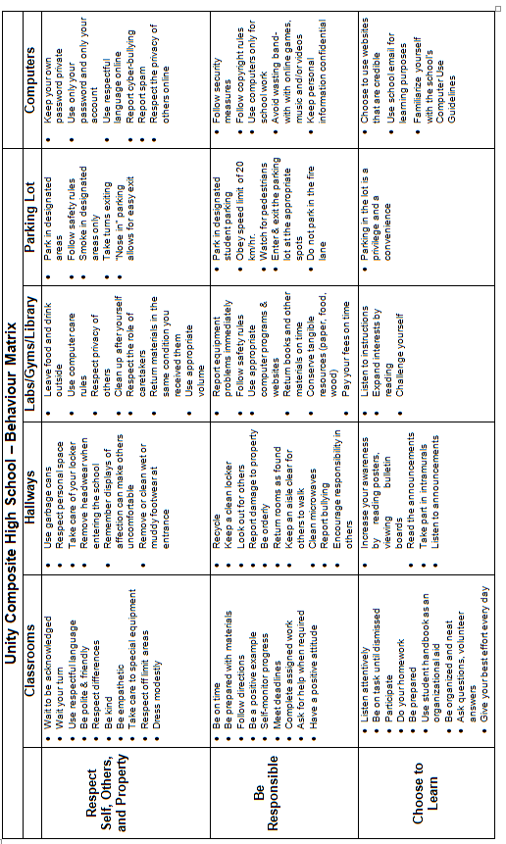
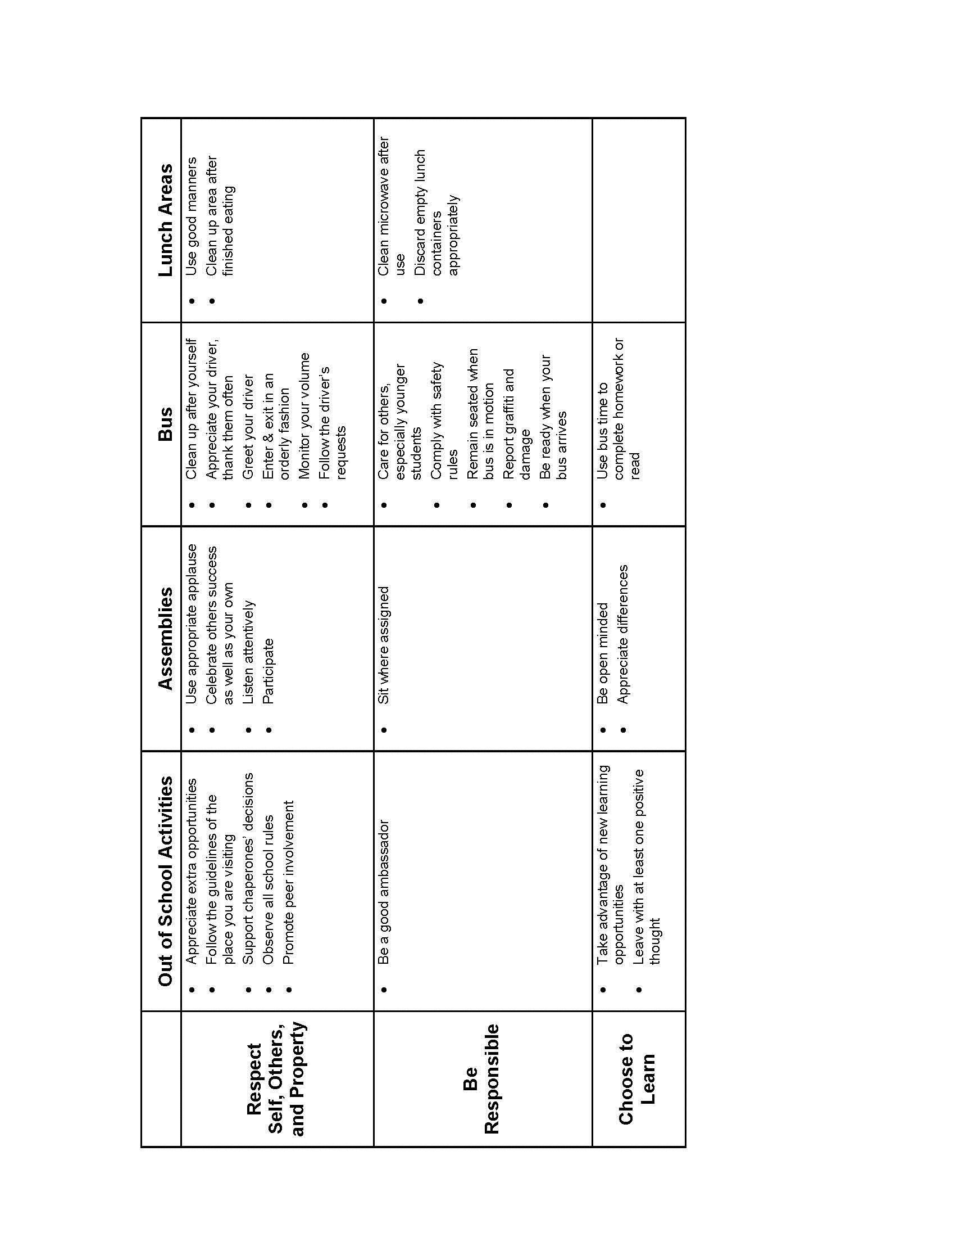
REPORT CARDS & STUDENT LED CONFERENCES
Report cards will be accessible at the end of each term. There will be student led conferences in November and in April.

LOCKERS
Their homeroom teacher will assign lockers to students on the opening day of school. School locks on lockers are mandatory. Homeroom teachers will distribute locks at the beginning of the school year. Loss of a lock will result in the student having to pay its cost of $10.00. Students are requested not to keep money or other valuables in their lockers. Students who need to exchange their lock due to others finding out their combination will be charged $2.00. No air fresheners of any type are allowed in lockers.

BOOTH
A booth with a variety of drinks and snacks for sale is operated for the convenience of students and staff. It is open during the lunch break and for tournaments. Profits from the booth are used to support a wide variety of extracurricular student activities at UCHS.

DRIVER EDUCATION
Driver education under the supervision of the Department of Education is offered free of charge to all students in the Living Sky School Division who are 15 years of age by the end of December of the current school year.

The course consists of both in-class and in-car training. Students must get signed permission slips one day in advance from each teacher whose class they will be missing for in-car training. Failure to do so will result in the cancellation of their in-car training for that day.

Students may not drive when they are scheduled to write a test in another class. Students are responsible for completing any work missed while driving.

CAREER EDUCATION
The Career Education program is aimed specifically at senior high students. This program is designed to make students more aware of career opportunities and training programs and to assist students in the selection of subjects to prepare for post secondary education. Mr. Melnyk and Mr. Parker are the career counselors. They will deliver aptitude testing with grade 11 students and assist every grade 11 student with a job shadow.

Career Education information is published on the UCHS website and in Sr. High Google Classrooms on a regular basis to inform students of scholarship opportunities, open houses, application deadlines and other career information of general interest. Meeting application deadlines is the duty of the student. Students will need to check the website for information regarding scholarships at https://uchs.livingskysd.ca/.

PERSONAL COUNSELLING
This program is designed to help students who are experiencing personal problems that may or may not be school related. Ms. Simoneau is the school division counselor. Students are encouraged to talk to a trusted adult in the school about accessing this service.

LIBRARY RESOURCE CENTRE
The role of the Learning Resource Centre/Digital Maker Space is to provide access to a wide variety of resources that are chosen to support the curriculum and meet the needs of staff and students. There are iPads, Chromebooks, and laptop computers in the Library, which allow the students to access their personal files, the Living Sky email system, and the internet. All students must have proper UCHS password clearance to use the computers. The UCHS Library uses an automated library system, OPAC (Online Public Access Catalogue) which allows patrons to use keywords to locate items and books.
The Resource Centre/Digital Maker Space is open Monday-Friday from 8:30 to 4:00 p.m. One day a week the Library is closed all noon hour. Hours are posted on the door. Students are encouraged to use library materials for class work and for their own enjoyment. Food and drink are not allowed in the Library.

COMMUNICATIONS WITH STUDENTS AND THE HOME
THE NEWSLETTER & SCHOOL MESSENGER SYSTEM
UCHS newsletters are published monthly on the school website and emailed to parents each time a newsletter is published. The newsletter provides information about courses, programs, registration and events at Unity Composite High School.
In addition, information regarding up-coming events, school policies or time sensitive emergency situation information will be sent to parents through the school messenger system, which will send text, email, and/or a voice message directly to your home phone or cell phone. Contact the office for more information.

THE UCHS WEBSITE
Unity Composite High School’s website can be found at https://uchs.livingskysd.ca/ .The website lists current activities, events, newsletter links, teacher contact information, and scholarship information/links.

SCHOOL-WIDE COMMUNICATIONS
Notices to the entire student body are best routed through the morning announcements, which are read over the intercom every morning at 9:00am and posted on the monitors throughout the school. Announcements are also available on the school Facebook page.

SCHOOL POLICY

School Policy is to be in alignment with and is to be understood through the dictates of:

- The Positive Behaviour and Supports Program
- Unity Composite High School’s Mission Statement
- Unity Composite High School’s Vision Statement

STUDENT ASSESSMENT
Student promotion is based on ongoing assessment curriculum outcomes. Teachers will provide an outline of the expectations for each class. Promotion to the next level will be based upon achievement of outcomes, based on summative assessment of performance tasks, assignments, and examinations.

In Junior High, students will be assessed on each curriculum outcome according to a four point rubric scale with 4 signifying “mastery,” 3 signifying “proficient,” 2 signifying “approaching,” and 1 signifying “beginning”. Students are expected to have assignments completed on time, and to have all the required books and materials when they enter class.

In Senior High, percentage marks will be determined and then submitted to the Ministry of Education for transcript purposes. As stated in the Living Sky School Division #202 Assessment Handbook August 2015), only students who have submitted ALL of the required summative evidence of learning for a course will attain credit for the course.

The school division’s handbook also offers the following specifications, with regard to student assessment in Senior High:
- Teachers will clearly communicate summative assignment due dates throughout each term.
- Students will adhere to these due dates, and when deadlines are missed will be offered school-based interventions to ensure that summative work is completed in a timely manner for feedback and for the assessment of current achievement. A hard deadline of 3 days prior to final mark submission will be enforced. Teachers do not have to accept overdue assignments after this date.
- Regardless of reasons for absences, students must complete all summative assessments deemed by their teacher to be necessary in the collection of triangulated evidence for an accurate grade to be determined for each outcome or course (high school).
- Teachers, in consultation with their principal, will determine final dates for submission of assessment evidence to be included for a course’s grade. These dates will be clearly communicated to students.
- Students who request to reassess must show evidence of additional learning. Teachers decide what is reasonable and the parameters for re-assessment.

Summative Assessment Days are scheduled at the end of each semester. As these days are very important to perform assessment or reassessment, families are asked to avoid making plans that would interfere with student attendance at this time.
COMPREHENSIVE STUDENT ATTENDANCE POLICY

Statement of Overall Objectives:
School attendance is both a right and a responsibility. Unity Composite High School is an active partner with students and parents in the task of ensuring students meet or exceed the attendance requirements of Unity Composite High School and the Saskatchewan Education Act, 1995. Unity Composite High School recognizes that consistent attendance, academic success, and school or grade completion have a positive correlation.
Unity Composite High School is committed to the full implementation of sections 156 to 162 of the Saskatchewan Education Act, which clearly defines student attendance as a responsibility that is shared among parents, students, teachers, principals and the Board of Education.

As stated in the Education Act, parents and guardians are expected to:
- Ensure that their children attend school and arrive punctually every school day (Section 156, Saskatchewan Education Act, 1995).
- In a timely fashion, phone or provide the school with a dated and signed written excuse in the event that their child is absent or late.
- Act in accordance with Section 162 of the Saskatchewan Education Act, 1995.
    - No parent or guardian or other person shall:
        - Neglect or refuse to give to a teacher or principal any information with respect to a student’s attendance as outlined in the Act.
        - Give false information
        - Interfere or attempt to interfere with the carrying out of the provisions of the Act pertaining to school attendance.
        - Directly or indirectly, attempt to influence improperly any decision of a teacher or principal in the enforcement of any provision of the Act pertaining to school attendance.

- Communicate with their children about the importance of daily attendance and punctuality and their effect on learning and achievement.
- Support their children to complete homework following absences due to holidays

Leaving School Early Policy:
If leaving school during regular school hours, Grade 7 to 12 students must have their parent’s permission and permission from the principal or vice-principal by completing an Early Leave Form at the office in advance of their departure. One form must be presented to the classroom teacher and one will remain in the office. Students must get their Early Leave Forms signed before 8:55 am in the morning and before 12:30 pm in the afternoon. Students who leave school without getting an Early Leave Form signed will be marked absent. Grade 12 students will leave the school during their “spares” without getting an Early Leave Form signed.

TECHNOLOGY & COMPUTER USE POLICY
With permission of their parents or guardians, students at Unity Composite High School are provided with the opportunity to access the Internet and use computer systems in the school. Each student is responsible for their own actions while using the computers. Uses that might be acceptable on a user’s personal computer or on another system may not be acceptable on school computer systems. The computers are school property and any communications or materials used on the system will be monitored.

CELL PHONE & ELECTRONIC DEVICES POLICY
Cell phone usage in the classroom is for educational purposes only. If cell phones are brought to the classroom, the supervising staff member may require they be placed in a designated location and only removed with permission.
Cell phones, iPods/Pads, Smart Watches are not to be brought into rooms in which tests or exams are to be written.
The school is not a public building and photos and videos should not be taken unless for educational purposes.

GENERAL COMPUTER USE
- Technology and equipment will only be used in ways for which it was designed. Users may be held responsible for any or all damages that are the result of negligence or inappropriate behaviour.
- Passwords will never knowingly be given to others
- Users are restricted to using their own password/account
- Students will never knowingly circumvent, or try to circumvent, security measures on any school computer
- Students will never attempt to install any computer program on a school computer without permission from the network administrator
- Copyrighted materials will not be stored on any school computer or server
- Users will periodically remove unneeded/outdated documents from their accounts
- School computers will not be used for personal profit
- Permission of a teacher/administrator must be gained before printing any documents (including web pages) for personal interest.
- Student printing accounts will be suspended once they have exceeded the acceptable limit of pages and be required to pay $5.00 to reactivate their account.
- Computer systems, the Internet and E-mail Accounts may not be used to view any type of inappropriate website (eg. Pornography) or to engage in non-academic or unapproved conversations.

PASSWORDS AND BACKUPS
Each student has access to a OneDrive & Google account with a unique username on the school computer system. Each account is accessible with a private password from any location. Passwords should be memorized and kept secret. Should a username or password be forgotten, the network administrator is to be contacted.

INTERNET AND SCHOOL DIVISION EMAIL USE
The proper use of the internet, email and the educational value to be gained from their use are the joint responsibility of students, teachers, and parents. Every student and their parents must sign both a UCHS and a Living Sky School Division agreement declaring that they will abide by all of the rules set out regarding Email Account and Internet use. Students who break these rules will have their accounts suspended.

BEHAVIOURS AND CONSEQUENCES
The use of the school’s computers is a privilege, not a right. The network administrator and school administrators will determine what constitutes appropriate use of the school’s computers. Their decision is final. Administrators, teachers and staff of the school may request action to be taken regarding specific user privileges. Depending on the nature and the degree of the infraction and past history, unacceptable use of the computer system or Internet may result in one or more of the following consequences:

- Suspension of access privileges
- Cancellation of access privileges
- Payment for damages or repairs
- Discipline under other appropriate school policies

DANCE RULES & POLICY
- Dances are open to all UCHS students; other students must be signed in as guests, 2 guests / Junior High student, 5 guests / Senior High student. Students must accompany guests to the door and are responsible for their actions at the dance.
- Doors close at 10:00 P.M.
- Students and guests shall adhere to the policy supporting a drug-free environment.
- Students attending dances are subject to UCHS’ Ensure Breathalyzer and Deterrent Drug Test Kit Policy
- Students who are removed from a dance for any reason may not attend another dance for the entire school year.

ALCOHOL / RESTRICTED DRUGS POLICY

The use of tobacco and tobacco replacement products, alcohol, or illegal drugs is not allowed on school premises, nor should they be used prior to any school activity. Students found under the influence or in the possession of restricted substances during any school activity will have their parents notified and the RCMP may also be contacted. The student may be suspended from school and from further participation in extracurricular activities.

SMOKING & E-CIGARETTE/VAPE POLICY

- Students are not allowed to smoke or vape on school property.
- Students may not smoke or vape between classes.
- Students participating in extracurricular events are not allowed to smoke or vape during school-sponsored activities or frequent the smoking areas.

STUDENTS IN VIOLATION OF TOBACCO/E-CIGARETTE POLICIES ARE SUBJECT TO SCHOOL DISCIPLINE AND FINES.

SAFE SCHOOL POLICY
Students are not to bring weapons, including pocket knives or replica weapons to school.

STUDENT PARKING POLICY

Students are to park in the designated student parking area. Staff parking is restricted to staff and visitors only. All others will be towed at the owner’s expense. Vehicles are not to be parked in front of the school on either side of the street during school hours. All vehicles are to be parked to allow for the most space in the lot to be utilized. Snowmobile and recreational vehicles are not permitted to be parked in the student parking area or along streets near the school. It is a privilege to park in the school parking lot. Failure to use the parking lot in a responsible manner may result in the loss of this privilege.

FIELD TRIPS AND EXCURSIONS POLICY

Field trips and other excursions play a valued part in the educational program at UCHS. Students, while taking part in such excursions, are subject to all the rules, policies and expectations of the school, just as though they were in school. While on field trips and excursions students are under the direction of teachers and/or chaperones appointed by the Principal or Vice-Principal. In order to be eligible to attend field trips students must pay all necessary fees and have consistently demonstrated UCHS’ three beliefs of Respect, Responsibility and Choose to Learn.

SCHOOL DRESS POLICY

Students are expected to attend school suitably dressed. During warm weather, students may wear shorts in class providing they reach mid-thigh. Clothing which is unacceptable includes alcohol / drug related shirts and hats, shirts displaying inappropriate language or graphics. Also unacceptable is clothing that allows underwear to be displayed. Headwear may be worn to school but may not be worn anywhere in the school or at school-sponsored functions during the school day. Headwear is defined as anything covering the students head such as hats, toques, hoods, and/or sunglasses.

ENERGY DRINKS POLICY

Energy drinks are not allowed in the school at any time.

UCHS PROGRAM INFORMATION

COURSE REGISTRATION

Students in Grade 10 and 11 will enroll in 10 credits each year. Grade 12 students must register for a minimum of 7 credits each year. It should be noted that given timetable constraints that it is very unlikely that a student will be placed in all of their chosen electives. Therefore, it will be necessary for students to be assigned to one or more electives that they did not choose. This situation is regrettable, but entirely necessary so that students may achieve all of the necessary credits for matriculation.

DROPPING A SUBJECT

Students are expected to complete classes once they are enrolled in them. Timetable changes after the first week of classes will NOT be permitted.

Students may not drop a subject without completing a ‘Course Change Request’ form and requires permission of both the student's parents and the Administration.

PHYSICAL EDUCATION

Students medically unfit for certain Physical Education activities must bring a certificate to that effect from their doctor before they will be excused from those specific activities.

Students are expected to wear proper gym shoes and clothing for Phys. Ed. Showers are provided and students are expected to use them.

In addition, the following rules apply to the use of the gym at all times:
- Gymnasiums may only be used when a teacher is available to supervise
- Runners must be worn for all Phys. Ed activities
- The stage in the Senior Gym is out of bounds to all students except those who have permission to be there
- No food or drinks are allowed in the gym

FUNDRAISING
As a fundraising project the UCHS student body carries out two fruit sale campaigns. They are in October and February.

The purpose of the major fundraising initiatives is to raise funds for student-centred activities and projects (see Clubs, Activities, and Teams). The SLC is given a portion of the monies that are fundraised to offset the costs of the many programs they run. There are incentives for students to participate in these drives in the form of prizes. Funds are distributed to groups who submit an application to the Fundraising Committee. The Committee reviews applications on a case-by-case basis. Students who fail to participate in fundraising may have additional or larger fees for activities in which they take part.

Thank you to the community for your continued support in these projects.

CLUBS, ACTIVITIES, & TEAMS

The staff of UCHS strongly supports the involvement of all students in extracurricular activities. However, since academic achievement is our primary goal, students may only take part in extracurricular activities providing their on-going academic achievement and behaviour have been judged to be satisfactory by their teachers.

INTER-SCHOOL ATHLETICS

Unity Composite High School has a strong tradition of inter-school athletics. Athletics helps students gain new personal and team skills and meet new friends, teammates, and coaches from many different communities. Teams are offered in volleyball, basketball, badminton, cross-country running, football, curling, golf, and track and field.

STUDENT GOVERNMENT (SLC)

The SLC initiates and coordinates activities to provide greater opportunity for students to participate in school affairs. Representatives of Junior and Senior homerooms on the SLC are involved in planning school activities such as dances and spirit days. The SLC supports projects (including a child through the Foster Parents Plan), student exchanges and forums, environmental projects and the student diary.

The SLC Executive consists of two Council Co-chairs, a Secretary-Treasurer, and the chair people of 6 committees: Aesthetics, Communication, Spirit, Special Events, Fundraising and Intramurals. Members meet weekly to plan activities, build spirit through communication, and develop leadership skills.

Students are charged a $25.00 student fee. The fee is divided up as follows:
- $15.00 - SLC fee (Student Representative Council activities)
- $10.00 - activity & program fee (guest speakers, swimming pool, insurance, etc.)
Student fees and admission fees are collected to support student activities. The above fees are due at fall registration and are mandatory for all full-time students. Additional fees are collected for other activities including Yearbook, Industrial Arts, Home Economics and inter-school athletics.

PURPOSES OF SLC

- To provide students with experience in operating a democratic, representative government.
- To give students a "real" opportunity to express and support ideas that they believe are important.
- To plan social events to raise the "spirit" of the student body.
- To influence the social "rules" of the school; to provide a way of lobbying for changes in those policies consistent with the need for a school to be a place where good education can take place.
- To provide an "ear" to student ideas so that those ideas which capture the SLC's attention can be promoted to the whole student body.

To levy an activities and program fee to cover costs of renting space at the pool and rink, to cover insurance for students at school, and to fund special projects (dances, foster parent child, Concerts, Motivational Media, reimbursing speakers, student workshops and conferences).

SADD

The Unity Composite High School Students Against Drinking and Driving Chapter meets every Wednesday over the lunch hour to discuss drinking and driving issues.

SADD students work together to raise the awareness of problems related to drinking and driving with the hope that attitudes will change and fewer lives will be lost. Projects, presentations, discussions, conferences and many other activities occur. All students are welcome to join.

ACTIVATE TEAM
The Positive School Climate Committee, AKA “Activate Team” is a group of students, parents and staff who meet twice monthly to implement ways to promote respect, inclusion and empathy in our school. Their activities include planning lessons, booking speakers and reaching out to other schools through the Activate campaign.

DRAMA CLUB

The Drama Club performs twice during the year. Auditions for the fall presentation are in September with a public performance in early December.

In the spring a one-act play is entered in the Saskatchewan Drama Festival - a three day festival where schools compete with one another. Auditions and rehearsals for the spring presentation begin in January before exams.

Drama involves not only acting, but technical expertise. Lights, sound, set construction, and costume design all play an important role in bringing "the page to the stage".

YEARBOOK

The UCHS Yearbook Club is a hardworking group with an interest in recording the people, events, and activities of UCHS in a creative way. Under the guidance of faculty advisors, club members design and create the yearbook using computer technology. During the school year the club members are in attendance at school functions to "capture the moments.”

The UCHS yearbook contains high school memories and will increase in personal value as the years go by. If students would like to help put a yearbook together, or have a creative talent to share, come out to yearbook meetings or attend the workshops.

FAB LUNCH
Our library/makerspace is a busy time at lunch for students to take part in the programs that range from board games and cards, knitting, crocheting, origami, lego and robotics. All of these activities are free of charge and are run on a drop-in basis.

THE FITNESS CLUB

The UCHS Fitness Club was started to promote physical fitness among UCHS students. Due to the risk associated with intensive training on physically immature bodies, membership is open only to students in grades 9 - 12. Although basic program information is provided to members, their progress is essentially self-directed. An annual membership fee of $20.00 is charged in order to maintain existing equipment and to purchase new equipment. Students who do not join during the first week of school in September will be able to join at the beginning of the second semester for a fee of $10.00.

INTRAMURAL ATHLETICS

A noon hour intramural program offers a variety of activities. Some are organized and some are drop-in. Students are encouraged to participate in intramural activities to make their high school years more enjoyable and memorable and to build school spirit. Students are required to wear proper footwear and provide their own equipment when necessary.

UCHS EXTRACURRICULAR CODE OF CONDUCT

Decorum and sportsmanship refer to when students are participants as well as when they are spectators. The following code is a summary of true decorum and sportsmanship. S/He will:

- consider all opponents / other participants as guests and treat them with courtesy and respect, accept gracefully and without question the decision of officials, judges, or adjudicators.
- take responsibility for his or her actions while at events and during the transporting to and from events.
- never hiss, boo or make other disrespectful noises towards players, spectators, coaches, or officials.
- never utter abusive or irritating remarks from the sidelines, bench area, or spectator seating areas.
- give other participants full credit when they win or play well and learn to correct his or her own faults through failures.
- show respect for the game by seeking to win by fair means, according to the rules of the activity.
- participate and respect the activity for its own sake and not merely for the sake of winning.
- accept both victory and defeat with pride and compassion, being never boastful nor bitter.
- choose to learn from his or her participation in the event.

Eligibility Rules:

Attendance – The student must be in school prior to participating in practice or events. Students may attend extracurricular events if their absence during the day is a result of a funeral or a medical appointment. In the case of funerals a parent must contact the coach / administration prior to the commencement of the event. In the case of medical absences a note or phone call from a physician or a parent must be presented to the coach / administration prior to attending the event.

Tardiness – Habitual absences or lates during the regular school day may be considered grounds for ineligibility.

Skipping Classes - Students who skip classes may be ineligible to participate in practices or events for a period of one calendar week (7 days) from the date of the skip.

Dress – students are expected to dress appropriately for all trips. Students not in compliance with the team and/or UCHS student handbook dress policies may be excluded from the trip.

Transportation – Students travelling to events on school sponsored transportation are expected to return home on such transportation. Students may ride to an event or home with a parent /guardian. Students may travel with an authorized agent of the parent / guardian only when a written and signed note has been provided to the coach/principal by the student’s parents. When students are away from school at events the UCHS supervisor will have the final decision on the transportation of any student in their care.

Dispute Resolution – when a student feels that they have been unfairly deemed ineligible they may appeal to the principal. The principal may seek the assistance of coaches, supervisors, directors or others in making a determination regarding a student’s eligibility. The principal or committee’s ruling on the student’s eligibility will be final and no additional arbitration procedures will occur.

HONOURS AND AWARDS

HONOUR ROLL, AND PROFICIENCY AWARDS
In junior high, a student attains Honour Roll status by achieving proficiency status (3 or greater) on all course outcomes in at least 9 out of 10 classes. In senior high, a student attains Honour Roll status by achieving an overall average of 80% or higher.

AWARDS NIGHT
In early June of each year students, parents, and staff gather together to celebrate the academic, cultural, and athletic achievements of students over the year.

PROFICIENCY MEDALS
Proficiency medals will be awarded at Awards Night to students who have the highest average in each of grades 10, 11 & 12. The winners will be determined by averaging 7 subjects using the final marks from Semester I and Semester II (English A and B, Social Studies, the highest Math, the highest Science and the next two highest subjects). Five subject area awards will also be given in Senior High. The grade 12 proficiency medal will be awarded at the Cap and Gown ceremony.

EXTRA-CURRICULAR AWARDS

A point system recognizes participation and achievement in athletics.

Awards are available (1 Junior /1 Senior) in the areas of Arts and Culture for involvement in drama. Four awards are available (2 Junior /2 Senior) in the area of leadership for involvement in SLC, SADD, yearbook, athletics, Positive School Climate Committee, educational programs and school committees.

Two Citizenship awards are available for a Junior and Senior high student who demonstrated a positive influence based upon school attendance, school involvement, and respectfulness.

In recognition of the fundamental role that the Three Beliefs play in the daily activities of the school two students (1 Junior /1 Senior) are recognized with Three Beliefs awards for their demonstration of the beliefs of Respect, Responsibility and Choose to Learn.

GRADUATION EXERCISES

To take part in Graduation Exercises students must be taking at least the minimum requirements for Grade 12 graduation. Furthermore, as stated in the Living Sky School Division #202 Assessment Handbook, all major summative tasks must be completed for a student to receive a credit. All required credits must be completed for a student to graduate.

SCHOLARSHIP AND BURSARY AWARDS

At the end of April each year a list of local scholarships and an application package will be posted on our school website at https://uchs.livingskysd.ca/ .

BELL SCHEDULE & DAY CALENDAR
